Sunny –

Thanks for implementing the new color patterns yesterday into the chart. I feel its important to keep to this general color pattern to best describe each of the quadrants… and I have some ideas on how to further improve the visualizations overall.

Change #1

Enable responsive features:

Amcharts has a functionality that helps with chart responsiveness. The idea is to improve the charts when viewed on different devices types (such as desktop vs mobile phones). More about this feature can be read here:

<https://www.amcharts.com/docs/v4/concepts/responsive/>

My goal for this feature is the following:

* General responsiveness
  + I’m hoping to marginally improve the way the charts looked when loaded on a mobile phone. Right now, they look pretty good on mobile. But I have a feeling that implementing the “default rules” listed on that particular page in the documentation will further improve the formatting a bit
* Make text of annotations smaller based on a custom rule
  + This one will be a little trickier, but I think its doable. The text annotations on the Fat Tails and Options Accuracy charts looks pretty good on desktop but when loaded on mobile, the text size does not change and therefore the text ends up taking up the entire chart when loaded on a mobile phone. All the other features of the charts adapt to the new screen resolution except for the text. \*\* Is it possible to add a custom rule so that as the screensize scales down, so will the text size? I don’t know if its possible to make a rule quite as dynamic as that (maybe it is, that would be nice), but if not, maybe we can make a rule that if the screen size is below a certain size, the font automatically scales down to a certain degree. Part of the solution may be to make the default text size smaller, but I think adding a custom rule like this will help significantly.

Change #2

This one is easy… can the colors within tooltip of the fat tails chart also be changed to reflect the new color pattern?

New chart

I would like to experiment with a new chart type. For this one, I would like to create a horizontal bar chart for our PnL chart. The PnL chart is currently grouped together with the Volatility and Sharpe Ratio charts. I would like to try and pull the information out and isolate it for this chart.

I would like to create a horizontal bar chart somewhat similar in format to the one I produced in Altair below:

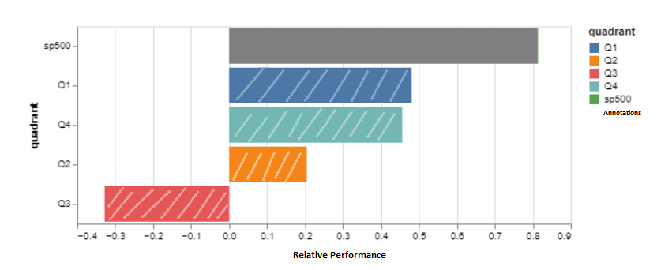

This chart has a few features which I will do my best to summarize below.

Colors, Gradients, Patterns

I incorporated for 4 of the 5 bars a diagonal line pattern. The documentation for implementing this can be found here: <https://www.amcharts.com/docs/v4/concepts/colors/> - and the intended output would look like the following screenshot:

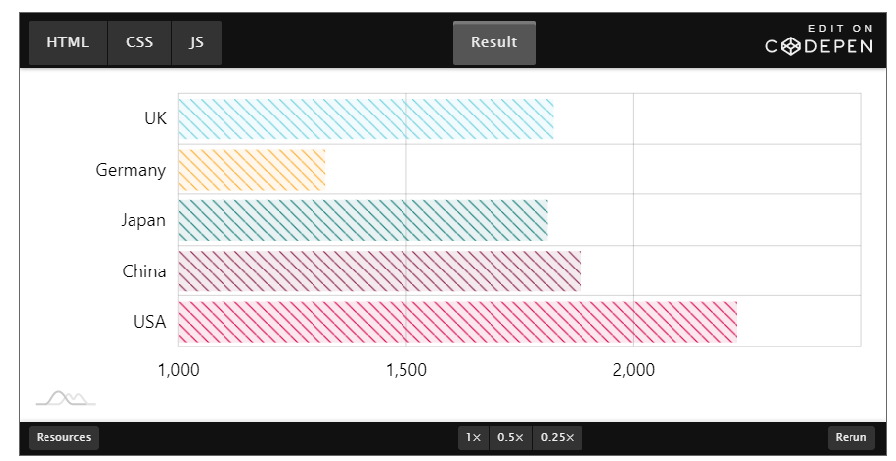

My goal is to make the bars for the CSI quadrants very interesting while making the bar for the S&P500 relatively boring and bland. I hope that this contrast will make the CSI quadrant bars stand out a bit more. To clarify, I’m hoping to implement this pattern on only the four bar for CSI while the bar for the S&P500 to be a flat and plain.

As for colors… lets do the following:

* Each of the CSI bars will have the color corresponding to the color codes from yesterday
* The S&P 500 bar will be a dull gray
* The color for the y and x axis labels will be the standard black color (so not colored like we implemented yesterday)

Annotations

I’ve included another screenshot below where I have added annotations. The intention of these annotations is to still show the red/green relative performance values of each CSI quadrant compared to the S&P 500. I know that it looks weird seeing the gray S&P 500 bar in the example being larger than the others (and the fact that it says 1x). It’s an imperfect example so please excuse the scale being off a bit, but I hope its able to convey the point.

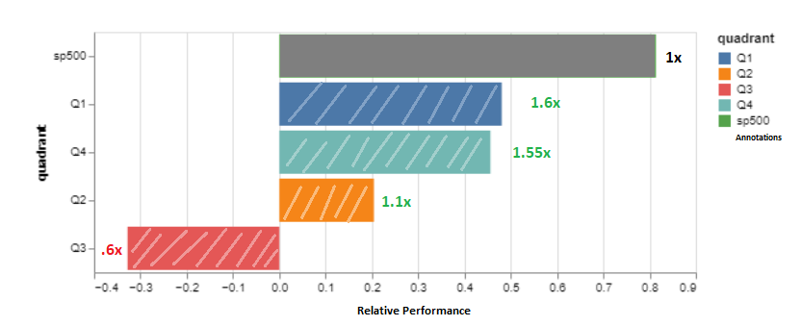

Automatic Sorting

The bars in the new PnL chart should be sorted in order of highest to lowest value (including taking into account the S&P500 bar).

Change #3

I saw the following example on the gradients/patterns page and think it can enhance our pie graph by adding more texture to each shape. Please see the following screenshot:

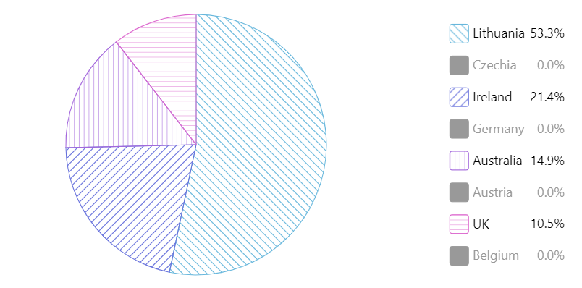

There are two options here…

1 – We can assign each of the four pie slices a unique pattern just like the example. We can stick to the line pattern… but just like the example, each line pattern is very slightly different.

2 – We can assign the same pattern to each slice of the pie. This may be ok because our pie chart already has an interesting feature where each slice is a different size.

I don’t have a theory on which of the two options will be best. Let’s try option #1 and see how it looks. We can always switch to option #2 later if we feel its better suited.